
Journal of Advances in Therapy published a BeOne-funded review article on FDT regimens in CLL
Company: BeOne Medicines  Drug: Sonrotoclax (BCL2i) | Date: Feb 10, 2026  Source(s): Review article
What happened:
- On Feb 2, 2026, the journal of Advances in Therapy published a BeOne-funded review article titled “Have Fixed-Duration (FD) Regimens Delivered on Their Promise in Chronic Lymphocytic Leukemia and What Is the Future of FD Regimens? A Narrative Review”
- The review highlights that fixed-duration regimens (FTD) regimens represent a positive step in the CLL/SLL therapeutic landscape, however, portrays Venclexta/ Venclyxto (venetoclax; BCL2i)- based regimens as disadvantageous in patients with high-risk features.
  - Sonrotoclax is noted as a potential next-generation solution, but the article concludes with the need for continued development to improve outcomes in all types of CLL/SLL patients.

Impact (CI PoV): MEDIUM
- BeOne continues to broaden its CLL franchise and challenge the use of Ven-based combinations by positioning Sonrotoclax, a next-generation BCL2i and Brukinsa (zanubruitnib; BTKi) fixed-duration therapy (FDT) combination as a competitor to CAPTIVATE (Ven+Imb) and AMPLIFY (Ven+ Calquence).

Why it matters (CI Insights in blue italics):
- The review notes shorter PFS with Ven-based FTD regimens in patients with higher-risk mutations (del17p and/or TP53mut), lower MRD negativity and PFS with VA, and the challenges of TLS management (especially in the community setting) – collectively positioning sonrotoclax to address key unmet needs in the FDT landscape.
  - This framing aligns with BeOne’s broader messaging strategy of emphasizing specific clinical and operation considerations to differentiate sonrotoclax, while implicitly reframing areas of unmet need within established role of Ven-based regimens.
  - Recall, BeOne recently initiated a head-to-head trial against AMPLIFY (VA, 1L CLL) reflecting the company’s confidence in Brukinsa + sonrotoclax and its intent to directly benchmark the combination against an established FDT regimen in 1L CLL, underscoring the company’s strong confidence in the combination.
- The article further emphasized that outcomes with Ven-based regimens vary by risk profile, stating that “PFS outcomes remained poorer in patients with high-risk features such as unmutated IGHV or del17p and/or TP53 mutations than in patients who lacked these features.”
  - Current, NCCN guidelines currently recommend three BTKi + BCL2i FDT options: Ven + Imb, VA ± obinutuzumab, and Ven+ zanubrutinib, each with varying recommendation levels but none yet FDA-approved. Notably, Ven + Imb is the only regimen specifically recommended as FDT for high-risk patients, underscoring the continued strength of Ven-based FDTs in guideline-driven practice.
  - This publication further augments BeOne’s strategy to prioritize zanubrutinib- and sonrotoclax-based regimens in IGHV-unmutated and TP53-mutated patients and complements the company’s “Test Before Treat” (TB4T) CLL Society campaign promoting biomarker-driven treatment selection.
  - Within this context, BeOne’s decision to pursue a head-to-head Phase 3 trial against AMPLIFY may reflect a longer-term effort to differentiate its FDT approach in genetically higher-risk population.
- The article includes a table (see below) comparing uMRD rates across multiple Phase 3 Ven-based trials in CLL using non-uniform MRD assessment methods, an area of increasing focus as uMRD gains prominence as an efficacy benchmark.
  - Specifically, CLL14, GLOW, and AMPLIFY report uMRD assessed at EoT+3 in the ITT population (“Best uMRD in PB”), while CAPTIVATE FD and MURANO report Best ITT uMRD rates, reflecting differences in endpoint definition and timing.
  - The article also highlights “substantially lower” uMRD rates for VA versus VI based on an indirect comparison (Munir et al., EHA 2025 abstract)
  - Without explicit acknowledgement of these methodological differences, HCPs may conclude that Ven-based FTD regimens achieve lower uMRD rates than sonrotoclax regimens, without recognizing these methodological differences.

Tell me more:
- The article describes TLS as a “complexity” of Ven-based regimens in community settings, citing close monitoring requirements and logistical challenges related to obinutuzumab administration (e.g., infusion chair time and infection/immune risks). In contrast, the sonrotoclax + zanubrutinib Phase 1/1b study is summarized as having reported no TLS events
  - This framing is consistent with BeOne continued to emphasis TLS management burden with Ven FTD regimens and the logistical challenges of obinutuzumab administration.
  - Recall, the Phase 1/1b trial data shows no clinical or laboratory TLS in 137 TN CLL/SLL patients, along with deep and early responses, including a 100% ORR at a median follow-up of 27.2 months.
- The article questions the efficacy and generalizability of VA, citing AMPLIFY’s exclusion of TPF53-mutaed and unfit patients and describing the regimens as having “suboptimal efficacy” with low uMRD rates and less favorable 3-year PFS
- The table comparing uMRD rates in multiple Phase 3 Ven-based trials:
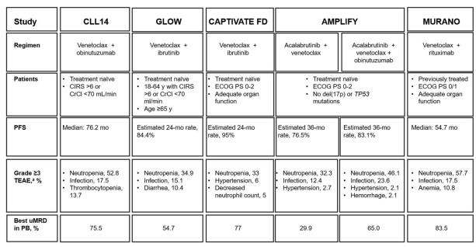

For questions, please reach out to:
International / Affiliates: Harjit Bajwa
US: Richa Sharma
Corporate Strategy, R&D and PCS: Claudia Lanauze Torres

Invite your colleagues to CI Edge | Manage Email Preferences | Unsubscribe

This document contains competitive intelligence collected via APEX/IMABI approved methods or vendors. We collect competitive intelligence consistent with industry standards and AbbVie policy. Not for commercial field distribution. Please reach out to AbbVie Legal or OEC with any questions

